Noah Wilkerson

*Project #1 Instructions: The goal of your reflection document is to 1) explain your design choices, and 2) explain the techniques you used in the program. Be sure to use proper terminology (for example elements, opening tag, closing tag, etc.) in your reflection. Demonstrate you understand the design concepts and the software you used to create your site. Make sure you proofread your reflection, so it is free of errors.*

**Explain the thought that went into organizing your site, keeping in mind the user experience.**

My idea is to make it easy for people to use and navigate. I want the nav bar to include icon links to sites such as instagram, facebook,paypal. On the home page the idea is to have a video from last week's sermon updated every week. I wanted all the pictures and videos located in one page like a gallery page. I wanted the ministries page to show the different classes that are offered and any other classes / services we do.

Explain your use of HTML and how your site conforms to HTML standards and accessibility standards. Be sure to discuss how you semantically marked up your content.

| **HTML** | **Where is it** | **Explanation** |
| --- | --- | --- |
| Contain a header and footer tag with applicable content | Above the nav bar. | The header will include a background image and icons for Instagram,Facebook,Paypal |
| Contain a navigation bar (on each page - navigation should be consistent across the site) | Right under the header information | The nav will include the logo |
| Two different levels of headings | I have an h1 in the heading of welcome to FBC of Mulberry and h2s to highlight the video link and the tithing link | I want the h1 to be on every page like a welcoming to the site. |
| One list or table | On the home page, there is a list under the welcoming and image. | A list of the classes including at the church |
| Three different inline elements in your text on the site (p. 89 has a table) | I have a small element located in the footer and some above the tithing picture. | I include the small elements because the one above the tithing is just supposed to be a little help for the users. |
| Contact info (it can be fake - for example 555- 555-5555) with a phone number | On the contact page | I have it only on the contact page right now so it is easy to find |
| A link to at least one external page | I have links to external pages in the header and home page. | I have icons to the churches accounts and locate them in the header so people can find them right at the top |
| Images (keep in mind websites do tend to be very visual so you will likely use more than one image throughout the site) | Images on every page. | I have pictures of the church on the home page, pictures of the staff, pictures of some of the classes and services. |
| Include any items above the minimum | Contact page has a contact form | Easy to use forms for those who need to contact us, I looked up how to make the form online. |

**If you went beyond the minimum requirements for this assignment, please explain here how you did so.**

**Show a screenshot(s) of your site validation for EACH html page.**

**index:**

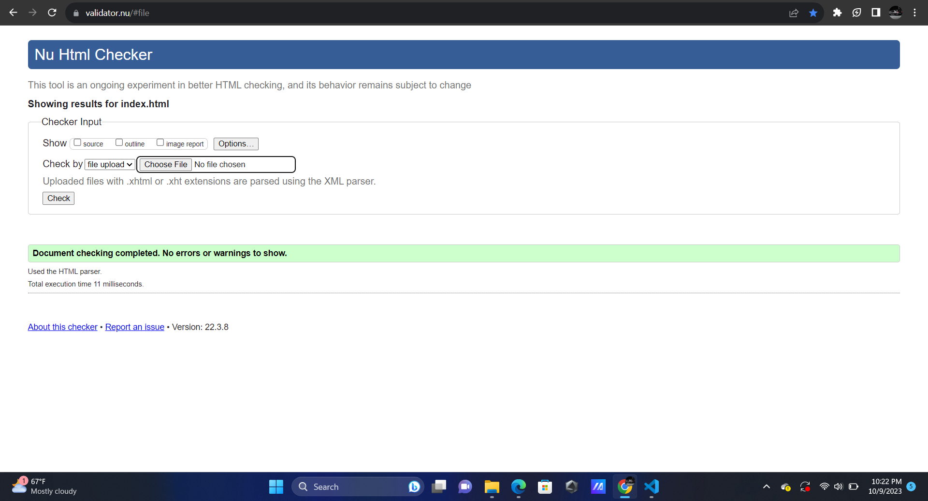

**contact:**

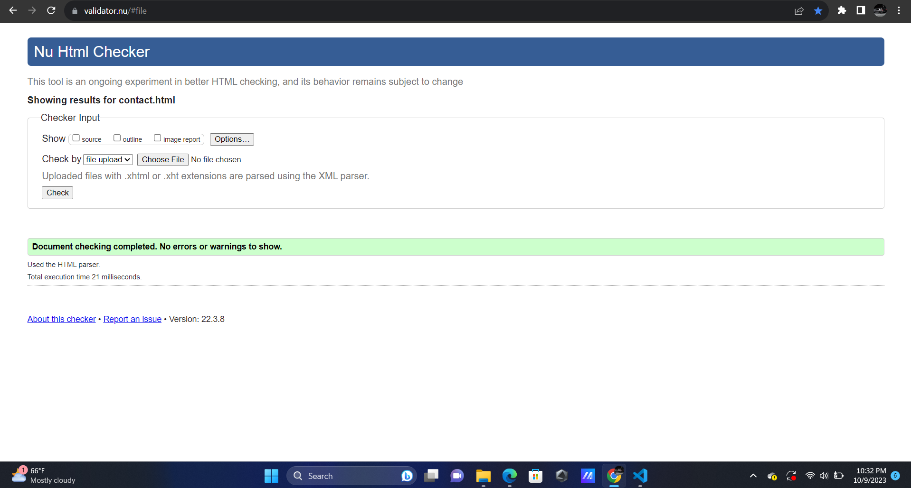

**Calendar:**

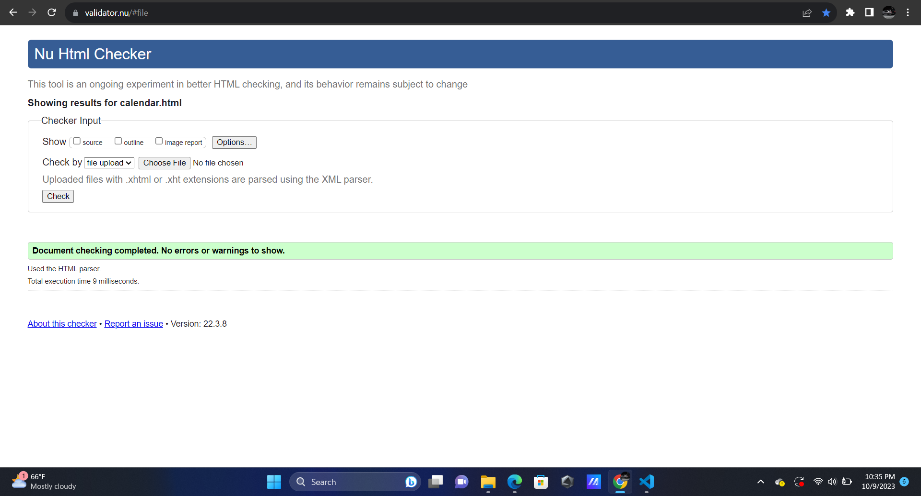

**Gallery:**

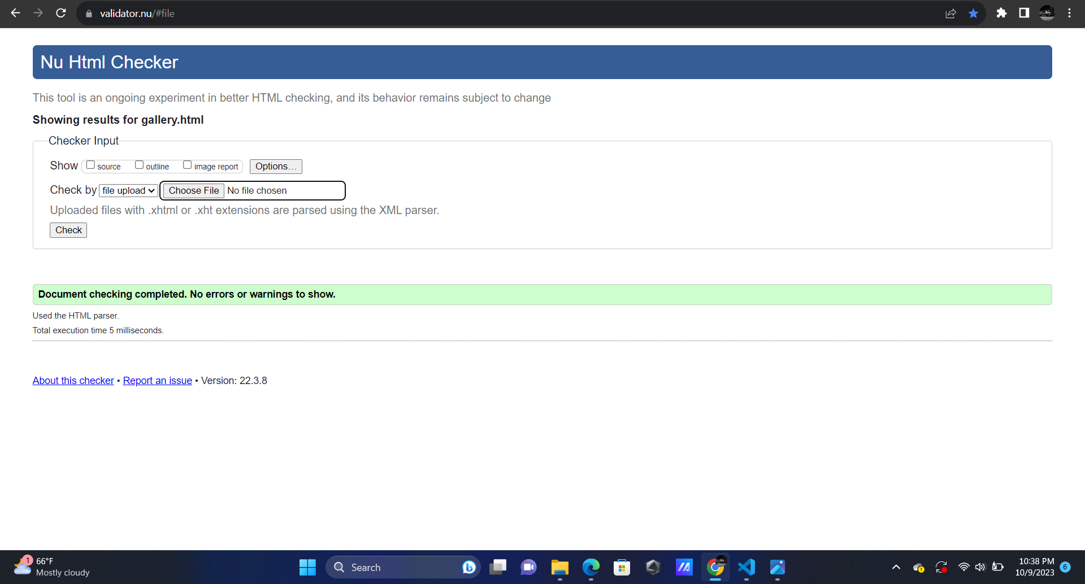

**Ministries:**

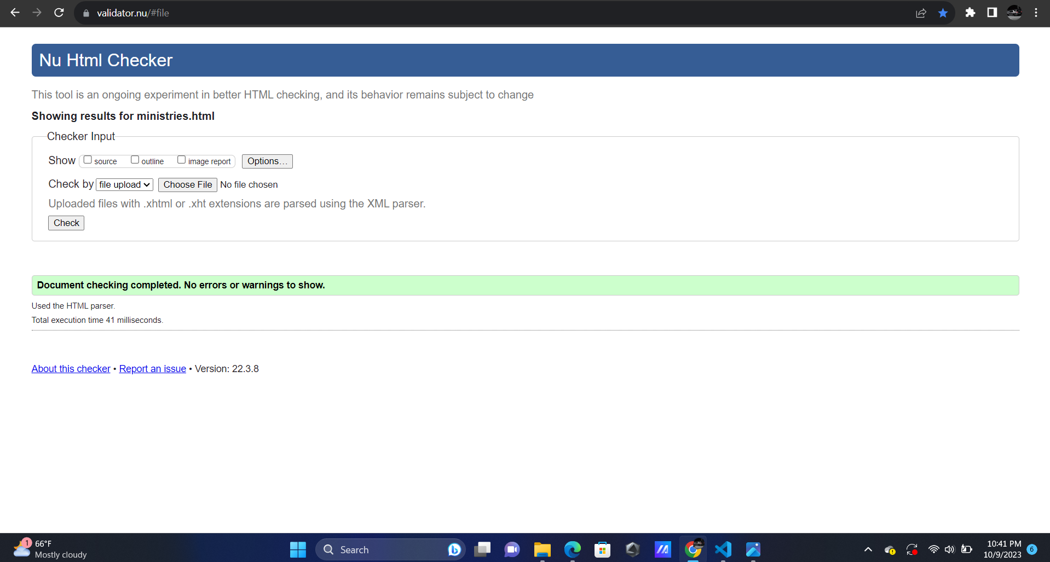

**Staff:**

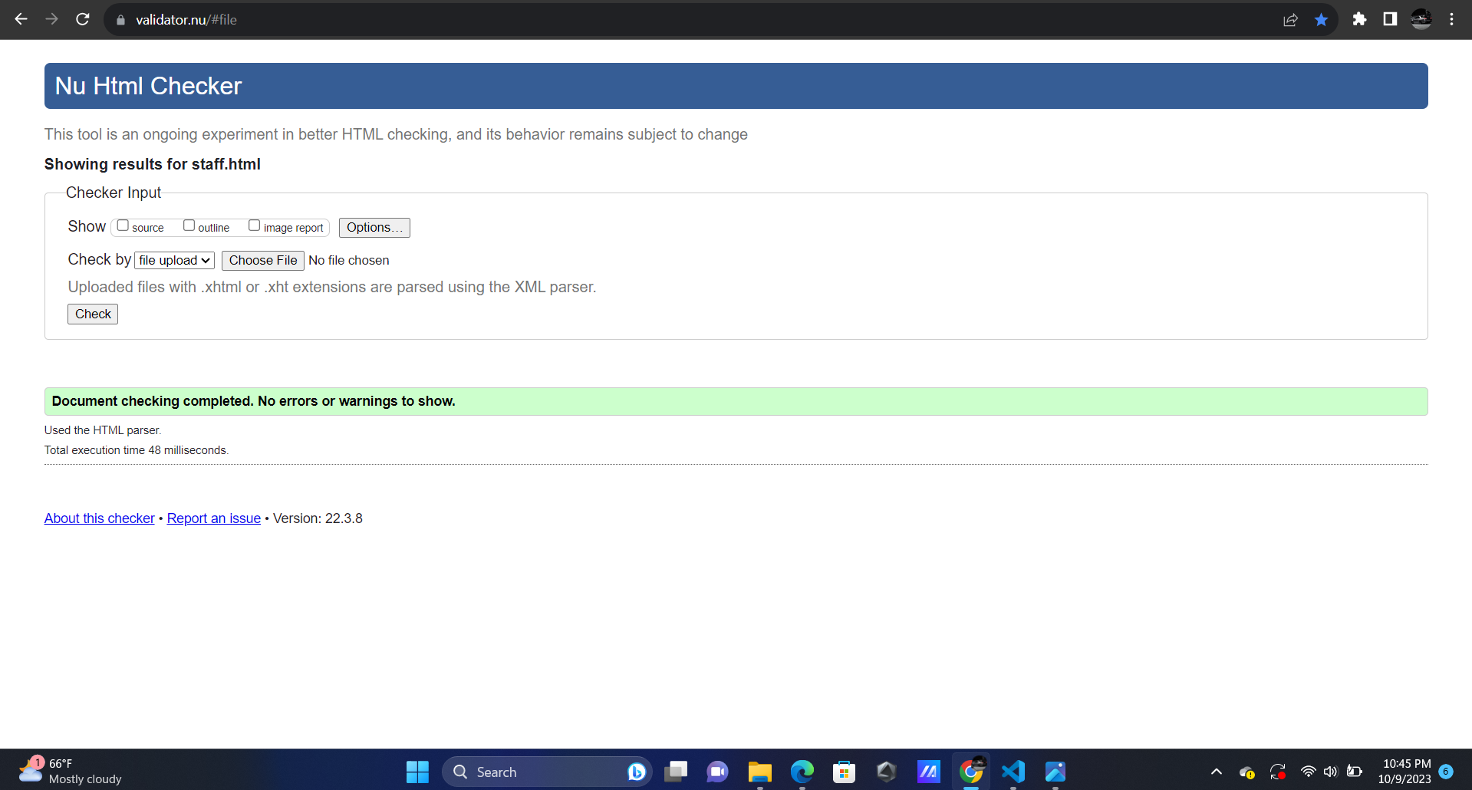

**Explain your revised submission:**

1. **Explain the feedback you received in class**

My first submission was not completed except the home page but some of the feedback I received is that the video idea that links right to youtube was a good idea and to change where i put an image and icons above the nav bar to make it make more sense for the site and another thing was make sure my files are named and filed correctly.

1. **Explain your thorough review of your own work. Then, be sure to illustrate how you elevated the project from the first draft to the revised submission (both through suggestions from feedback day and your own review of your work).**

It was my fault for not having it all completed but I think I have a good idea, I just need to put a little more care and thought into it. The main thing I tried to improve on is having more content and being organized.

1. **Include a screenshot of your first draft compared to the revised draft to showcase key updates you made.**

I was trying to look for the file of my first draft and the file is on the computer at the school, there was nothing on the other pages of my site and I added the content for those.

